ePals Global Community® Parent Information and Consent Form

Dear Parent,

Exciting news! Our class will be participating in a collaborative exchange with students from around the world on ePals Global Community®! Participation in ePals Global Community is intended to engage students in meaningful exchanges with students from around the world to build cross-cultural understanding, practice language skills, and share perspectives on different topics. Use of the ePals Global Community® platform has been approved by our school principal, is conducted online and will take place in our classroom and during regular school hours.

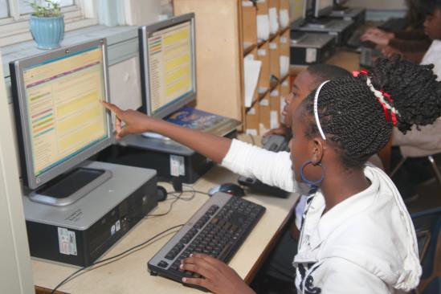
What is ePals Global Community®?
ePals Global Community® is an online platform where teachers and students from around the world can connect, communicate, and collaborate. Students participate in collaborations with students in other classrooms. Within a collaboration, students message other students about various topics or share ideas about student work. Teachers direct the sequence and purpose of student communications and they can moderate all messages, including any related content such as images, to help ensure student safety.

What about safety and privacy?
Cricket Media’s affiliate, In2Books, Inc., the provider of ePals Global Community® (together, “Cricket Media”), takes safety and privacy very seriously. No personal information about your child will be given to others outside of your school teacher, school administrators and Cricket Media or its authorized consultants, for administration of the program. Teachers are verified before they can join the community, and must observe strict policies as outlined in our Terms of Use and program guidelines. More information is also available at www.epals.com/privacy.

Why ePals Global Community®?
ePals Global Community® provides students an opportunity to extend learning beyond the walls of their classroom and into their larger local, national, or global community. By collaborating with students from across the world, your child gains the opportunity to develop knowledge about other cultures and share details about their own, practice language skills in an authentic context, and explore diverse topics that are relevant to a large audience.

Please do not hesitate to call the school if you have questions.
PARENTAL CONSENT
FOR STUDENT PARTICIPATION ON EPALS GLOBAL COMMUNITY®
I give permission for my child, ____________________________________ to participate in ePals Global Community™, which online class project has been approved by my child’s school/teacher. I understand that my child can receive messages from other students on the ePals Global Community® (“ePals”). I understand that it is the responsibility of my child’s teacher to moderate any student-to-student messages or any content, including images, that may be generated by my child in connection with his/her participation.
For a complete description of the information collected from participating children, how we use that information, and what information we share with third parties, please see those portions of http://cricketmedia.com/privacy which relate to ePals. I understand that I have the right to review the information collected about my child, and that I can later revoke my consent by submitting my request at support@cricketmedia.com to delete my child’s personal information from its database.
Child’s First and Last Name: ________________________________________________
Child’s Birth Date: ___/___/_____
Parent/Guardian Printed Name: ___________________________________________
Relationship to Child: ____________________________________________________

__________________________
Parent/Legal Guardian Signature Date Signed: __/__/__

*If you have any question regarding ePals or if you would like to speak with us about your child’s privacy, please contact us:
Cricket Media, Att: ePals Global Community
1751 Pinnacle Drive #600
McLean, VA 22102

